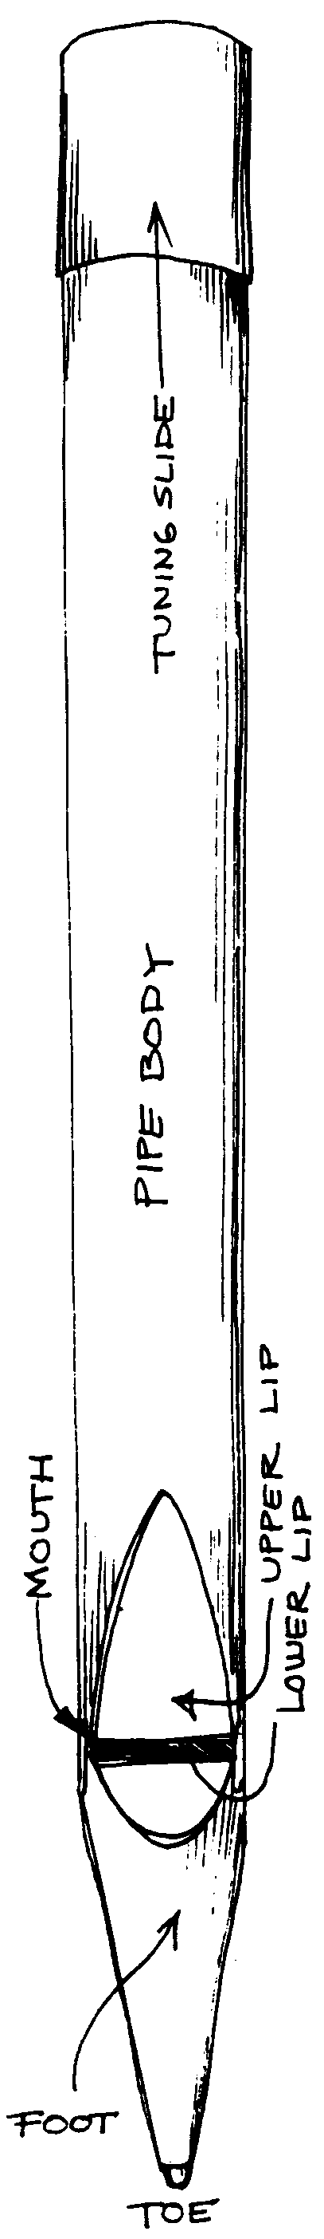
Literature Performed

Improvisation on Old Hundreth
Performer: Sebastian Lazo
Variation III | “Old Folks at Home”
Dudley Buck (1839-1909)
Performer: Justin Barber

Adagio in C für Glasharmonika
W.A. Mozart (1756-1791)
Performer: Justin Barber

Passacaglia and Pifaro on Nettleton William Allen Pasch (b. 1948)
Performer: Maggie Tran
Nun komm der Heiden Heiland
Dietrich Buxtehude (1637-1707)
Performer: Joseph Antonacci

Festival Toccata
Percy E. Fletcher (1879-1932)
Performer: Grace Neilson

Excerpt from Symphony No. 3
Camille Saint-Saëns (1835-1921)
Performer: Justin Barber

Herzliebster Jesu
Helmut Walcha (1907-1991)
Performer: Justin Barber
Chorale Prelude on “Lyons”
Mark Albrecht (b. 1962)
Performer: Justin Barber

Toccata from Symphony No. 5
Charles-Marie Widor (1844-1937)
Performer: Joseph Antonacci

UPCOMING EVENTS!
Halloween Spooktacular
Thursday, October 31, 7:20PM
Organ Studio Recital
Friday, November 15, 7:20PM

Notes from Demonstration

A rank is a row of pipes in one tone color.
A stop is the knob or tablet that turns a rank on or off.

8 foot ranks – same as piano pitch
4 foot ranks – sound one octave higher
2 foot ranks – sound two octaves higher
16 foot ranks – sound one octave lower
32 foot ranks – sound two octaves lower

The Andrew Anderson Memorial Pipe Organ contains 99 ranks and 5,396 pipes!

The keyboard(s) on the console
are called manual(s).
The manuals on this instrument are:
.
Bombarde
Choir
Swell
Great
Positiv

The larger the pipe, the lower the sound; the smaller the pipe, the higher the sound.

Mechanical action
makes use of long rods,
called trackers, which are
connected from the key
to the valve under the pipe.

In electrical action, the pressure of the
key activates a circuit to an electro-magnet
which opens the pipe valve.

There are five families of sounds distinct to the pipe organ: Principals, Flutes, Mixtures/Mutations, Strings,
and Reeds.

The zimbelstern produces a continuous ‘tinkling’ sound when activated.

Organists wear special shoes to facilitate playing on the pedal board.

